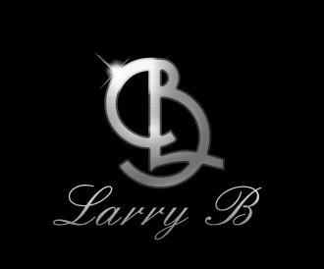

Biography of Larry Bedell

Larry Bedell, aka Larry B., musician, entertainer, and business man. Born in Springfield, MO, Larry is the eighth of twelve children of Leo Bedell, musician, and Katherine Bedell, gospel singer. At the early age of nine, Larry graced the stage while performing with his brothers Tommy, Joe, and Ernie. Also included were very talented neighborhood kids who were qreat musicians.

1964 – We formed,”The Fabulous Elites” which consist of a 16 piece R&B group and Review. The band toured the states in the mid-west for 8 years and disbanded in 1970.

1972 – Ernie Bedell, Richard Allen, and Larry Bedell formed, “KC Express” a 7 piece R&B band that toured the United States while signed with Stax Records Company in Memphis, TN. before disbanding in 1977.

1977 – Larry Bedell moved to Los Angeles, CA. and signed with Maverick Flats Talent Agency. Larry worked with such acts as Love Machine, Buzz Cooper, Gwynn Brisco, Pat Davis (first original soul train dancer), Howard Hewett, and Ralph Johnson of Earth Wind & Fire. Larry B. was music director for Buzz Cooper.

1985 – Larry B. moved his family to Dallas, Texas where he worked with locally known artist Greg Smith, the late Johnny Taylor, Clint Strong, (guitarist for Willie Nelson and family), and producer Phil York. Phil York introduced Larry B. to Dr. Doug Parker (Orthopedic surgeon for the Dallas Cowboys football organization).

1986 – Larry B. relocated to Fort Smith, Arkansas to join country rock group, “Grey Ghost”, under the management of Dr. Doug Parker. One year later we formed a great sound with producer Peter Sullivan, former president of Apple Records. Peter signed groups like The Beatles, Englebert Humperdink, and Tom Jones. Grayghost charted 16 songs in the top billboard 100. The group toured around the world performing at our military basses and concerts with such acts as Willie Nelson, Earth, Wind & Fire, Commodores, Asleep at the Wheel, Vince Gill, and many more. Grayghost appeared on Ralph Emory’s , Nashville Now, country music video, and Nashville Country Music Fest.

1993 – Present - Larry B. continues to reside in Fort Smith, Arkansas while creating his own personal band, “Larry B. & TCR” who currently performs to this day. Larry B. has become established in the music scene and well respected which is evident from the large fan base he has built over the years.

Razz-Ma-Tazz Entertainment Group, Inc. – P.O. Box 10901-Fort Smith, AR 72917-10901
Office 479.689.5105 - Cell 479.739.6492 Email beezmusic@yahoo.com

